Tools of Learning Reference Sheet
7th Grade Humanities

CONTENT IMPERATIVE ICONS
Name | Icon | Prompts | Personal Examples
Origin |  | How did this get started?  What caused this?  Where did this begin?  What caused it to begin?
Paradox |  | What are the things opposing each other?  What are the inconsistencies?  What is the dilemma?
Parallels |  | What is similar?  What is comparable?  What seems the same as?
Contributions |  | What is the value of this?  Which “ingredients” went into the total?  What factors or events helped make it what it is?
Convergence |  | What different types of things came together to cause this?  What were the meeting points?  How did everything merge?
Impact | 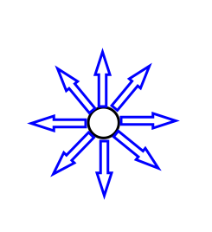 | What were the consequences?  Where might it go from here?  What were the effects?

DEPTH & COMPLEXITY ICONS
Name | Icon | Prompts | Personal Examples
Language of the Discipline |  | What terms or words are specific to the topic?
Details |  | What distinguishes this from other things? Find examples and evidence to support opinions & ideas.
Patterns | 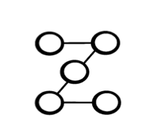 | Predict what you KNOW will happen next based on past events, with absolute certainty.
Trends | 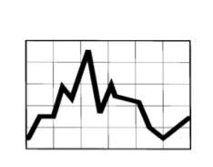 | Predict what you think MIGHT happen next based on past events, but are unable to know with certainty.
Unanswered Questions |  | A question about the topic that is, and mostly will always be, unknown. (ex: why is there pain in the world?)
Rules | 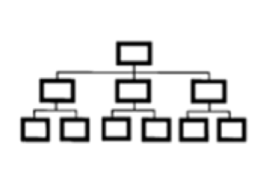 | How is it structured?  What guidelines govern it?  How is it a hierarchy or in order?
Ethics |  | What dilemmas or controversies are involved in this topic? Includes ideas of good vs. evil.
Big Idea | 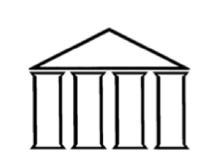 | What overarching statement best describes the main point of what is being studied or has been learned?
Relates Over Time |  | How do things change in the past, present, and future? How has time affected the information?
Multiple Perspectives | 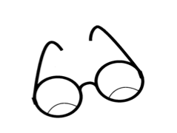 | What are the opposing viewpoints? How do different people and characters see this event or situation?
Across the Disciplines |  | How does this topic connect across different disciplines (school subjects like math, science and/or literature)?

